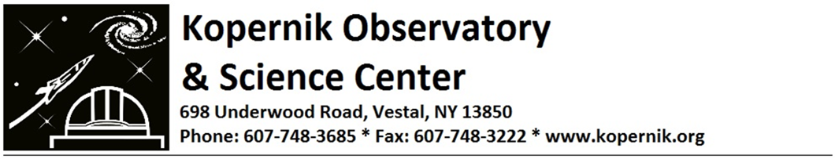
Dear Friend, November 2022
As 2022 comes to a close, I am happy to report that Kopernik continues to be a resource to the community for science, technology, engineering, and math (STEM) education and engagement. The pandemic certainly has modified how we operate; however, it also has given us new ways to reach a wider, global community. Friday Night programs, once offered only in person, now are also live-streamed on our Kopernik YouTube channel and watched by people from near and far. We also have live-streamed a number of astronomical observing sessions including the Lunar Eclipse in May which had over 25 thousand viewers that night. The recording of the livestream has been viewed nearly 600K times! Kopernik’s channel has become quite popular, with close to 13 thousand subscribers! If you aren’t already a subscriber, click on the QR code on the other side of the page.
Other highlights from 2022 include:
Winter Star Party was held in-person, featuring the assistant director for Science Communication at NASA's Goddard Space Flight Center, Dr. Michelle Thaller, who spoke about the promise of the recently launched James Webb Space Telescope.
At Rocketfest 2022, over 100 rockets were built and launched by individuals and families, hopefully inspiring the next generation of rocket scientists and engineers.
Kopernik Summer Camps gave 225 second to tenth grade students the opportunity to have fun while learning about STEM. Themes included coding, virtual reality, and the search for life in the universe. In one camp, students had the rare opportunity to speak directly with an astronaut on the International Space Station, using Kopernik’s Ham Radio station. You can watch the entire event by going to the following URL: https://youtu.be/rgtsklDzOKU
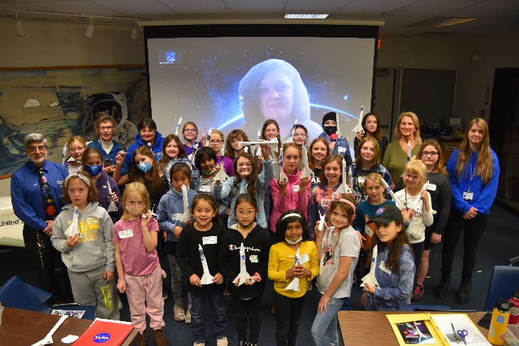
We hosted multiple school field trips at Kopernik this fall and have taken our portable planetarium to a number of schools and libraries.
In our spring Girl Power program, girls in third to eighth grades learned about the Science of Sound and spoke with a female livestream engineer from Harvard University and in the Fall, built rockets and spoke with a female rocket engineer who works at the Kennedy Space Flight Center.
Kopernik recently was awarded a grant from NASA to go to inner city and rural school districts to develop a program for hands-on activities that teach students in grades four and six what it will take to get astronauts to the Moon and Mars safely. Those programs will be delivered in early 2023.
NASA engineer who spoke to the Girl Power Rocket class
The Kopernik Science Park continues to draw families from all around the Southern Tier. It is a place where children can come engage with the structures and activities and learn how science and engineering are part of everyday life. We have used the park as a teaching lab for school groups that come to Kopernik and of course, it is a popular place at break time for summer camp students.
What is next for Kopernik and how can you make a difference?
In 2022 the Kopernik Board of Directors created a new Strategic Plan that will position us to more deeply engage in STEM education both in the school classroom as well as out in the community. Among the areas we plan to strengthen is our education staff. This will include hiring a Director of Education who will work to re-energize our current offerings, design new programs, and establish a stronger relationship with local school districts to become a valued partner as they start teaching to the new Science Standards. Ultimately, we expect the Director to create sufficient revenue to allow Kopernik to expand even further into the community with its programs and outreach.
We already have started working on a number of facility improvements, in preparation for the 50th anniversary of the Kopernik Observatory in 2024. This year we repaired and painted all three telescope domes and had to replace a failing HVAC system. We will need to replace our parking lot in 2023. If you are in a position to help us prepare for the Kopernik of the future, we would appreciate a donation in any amount.
All of us at Kopernik look forward to seeing you again soon, either at Kopernik or on our Livestream. We wish you a new year filled with bright moments and much joy.
Remember always to: Look up… Dream Big… and Stay Curious!
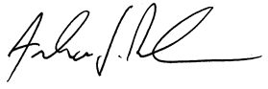

Andrew Deskur, Executive Director, Kopernik Observatory & Science Center

Year End Donation Options
check for $ _________ enclosed (payable to Kopernik Observatory)
charge my credit card $ _________ MasterCard Visa Discover
Card # ____________________________________ 3 Digit Security Code ______ Expiration Date ________
Name exactly as it appears on card: _____________________________________________________________
Billing Address of the Credit Card Statement: ____________________________________________________
Please complete and mail, email or fax this form with check or credit card information to:
Kopernik Observatory & Science Center, 698 Underwood Road, Vestal, NY 13850
ddeskur@kopernik.org 607-748-3222 FAX
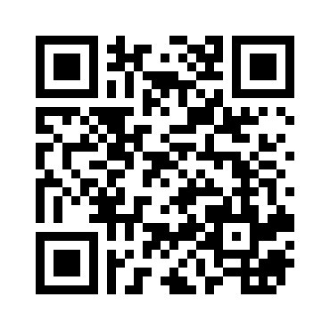
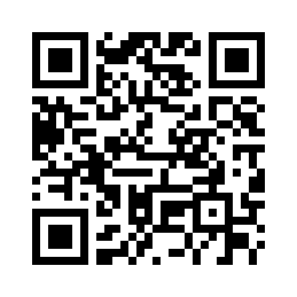
Online Donation
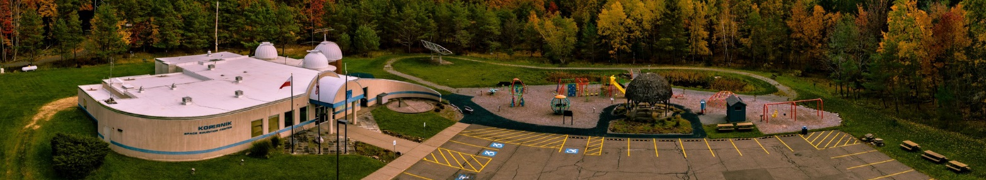
To make a secure online donation, go to:
www.kopernik.org/donations
or use the QR Code to the left to get to Kopernik’s donation page.
To subscribe to Kopernik’s YouTube channel
Click on the QR Code to the right and hit SUBSCRIBE

